Genzai script

CHAPTER 1: BEFORE IT HAPPENS

INT. KEVIN'S ROOM — NIGHT

KEVIN (20s, restless, hasn't slept) lies awake in bed, phone screen lighting up his face. A soft blue glow flickers beside him.

A small holographic figure — MISS MINUTES, his personal AI companion — stands quietly on the desk, watching him.

MISS MINUTES You've been staring at the ceiling for forty minutes, Kevin.

KEVIN (not looking at her) I'm thinking.

MISS MINUTES You're scrolling. That's not the same thing.

Kevin sits up, sets the phone face-down. Miss Minutes watches him a beat longer, says nothing else.

EXT. STREET / SHOP — NIGHT

Kevin walks alone past shuttered shops, streetlights buzzing overhead. He buys a bottle from a small store, doesn't say much. He drinks alone on the walk home, the hologram's blue glow trailing faintly beside him — present, but powerless to stop him.
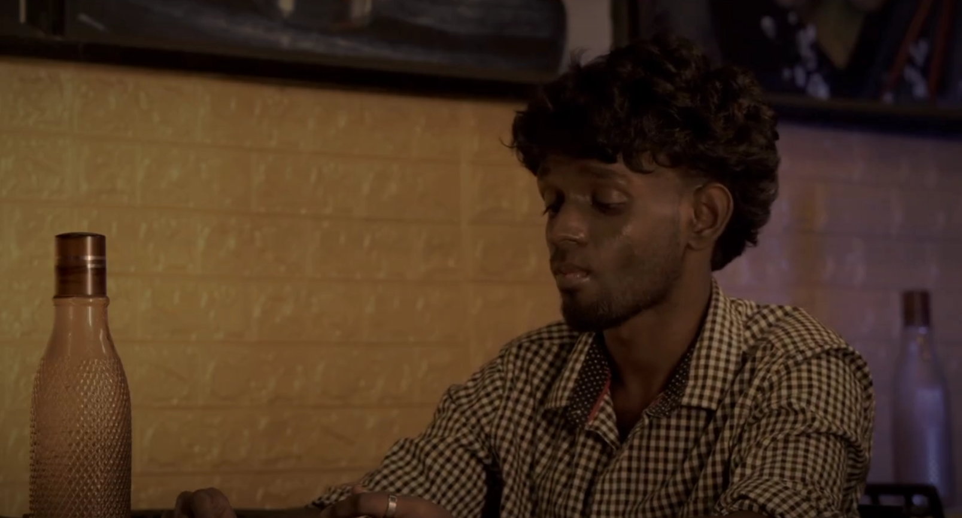

CHAPTER 2: THE ILLUSION OF CONTROL

INT. KEVIN'S ROOM — NIGHT

Kevin's phone rings. DAD'S NAME on the screen. He answers, distracted, irritated.

DAD (V.O., phone) Kevin — did you eat? Your mother's asking.

KEVIN (sharp, careless) I'm fine, Dad. Stop calling like I'm a kid. I have my own life to handle.

A pause on the line. Dad says something quiet Kevin doesn't really hear — he's already pulling the phone from his ear.

KEVIN (CONT'D) I'll call you back.

He hangs up before an answer comes. Doesn't notice Miss Minutes has gone very still, watching him.

INT. KEVIN'S ROOM — LATER

Kevin opens WhatsApp, thumb hovering over a message he'd sent to ELINA. He deletes it. "You deleted this message." He stares at the screen like it fixes something. It doesn't.

EXT. PARK — DAY (MEMORY)

Sunlight through trees. Kevin and ELINA (20s, warm, a little guarded) walk together, laughing. He leans in, flirtatious, confident — this is Kevin at his most charming, all easy smiles and lingering eye contact.

KEVIN You know you smile more when you're trying not to.

ELINA (fighting a smile) And you talk more when you're trying to hide something.

They sit on a bench. The moment lingers, tender — a version of Kevin who still knows how to be soft with someone.

INT. KEVIN'S ROOM — NIGHT (PRESENT)

Miss Minutes finally speaks, quiet and grave.

MISS MINUTES The way you spoke to your father tonight — that stays, Kevin. I can hold your memories. I can't hold your regret for you.

KEVIN (defensive) Since when do you lecture me? Just — do what you're built for.

MISS MINUTES I was built to help you see clearly. Not to keep you comfortable while you look away.

Kevin doesn't answer. The hologram flickers, dims — and doesn't come back on.
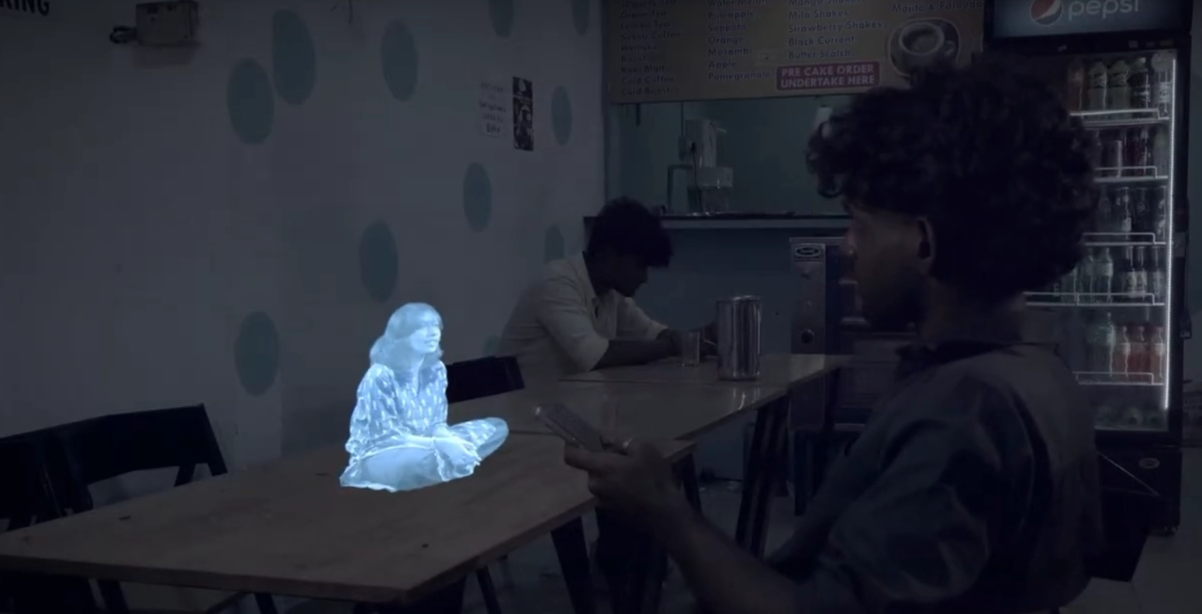

CHAPTER 3: THE COST OF TOMORROW

INT. FRIEND'S PLACE — DAY

Kevin sits with friends around a table, headphones, easy laughter — a normal day, almost. But his eyes drift to his phone. No blue glow waiting for him anymore.

INT. KEVIN'S ROOM — NIGHT

Alone at his desk. He tries to summon Miss Minutes out of habit — nothing. Just the empty air where she used to stand. He pulls up old photos on the phone instead, scrolling through memories the AI once organized for him — Elina, his parents, better nights. It's not the same without her voice.

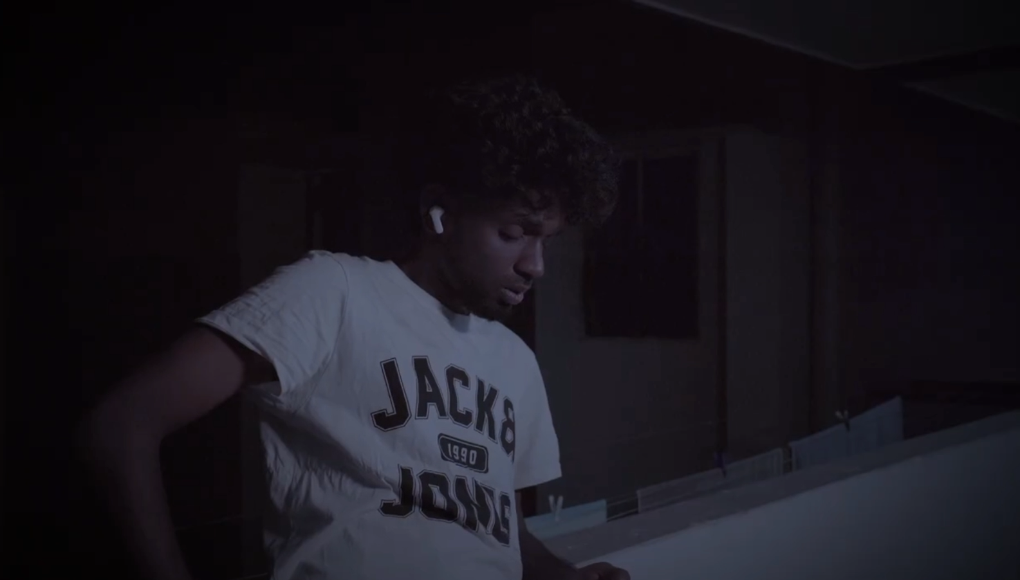

CHAPTER 4: THE QUIET BETWEEN

INT. KEVIN'S ROOM — NIGHT

No one to warn him anymore. No one to ask if he's eaten, if he's slept, if he's alright. He stops picking up calls from home. Stops asking questions he used to get gentle answers to. The silence isn't peace — it's just quiet.

Kevin sits at the desk, staring at nothing, the lamp the only light in the frame.

EPILOGUE: AFTER 2 YEARS

TITLE CARD: AFTER 2 YEARS

EXT. HOSPITAL — DAY

Kevin, older now, quieter, walks alone toward the EMERGENCY entrance. His father died some time ago — the details are never spoken aloud, only carried in how slowly Kevin moves, how his hand goes to his face once, wiping it before anyone can see.
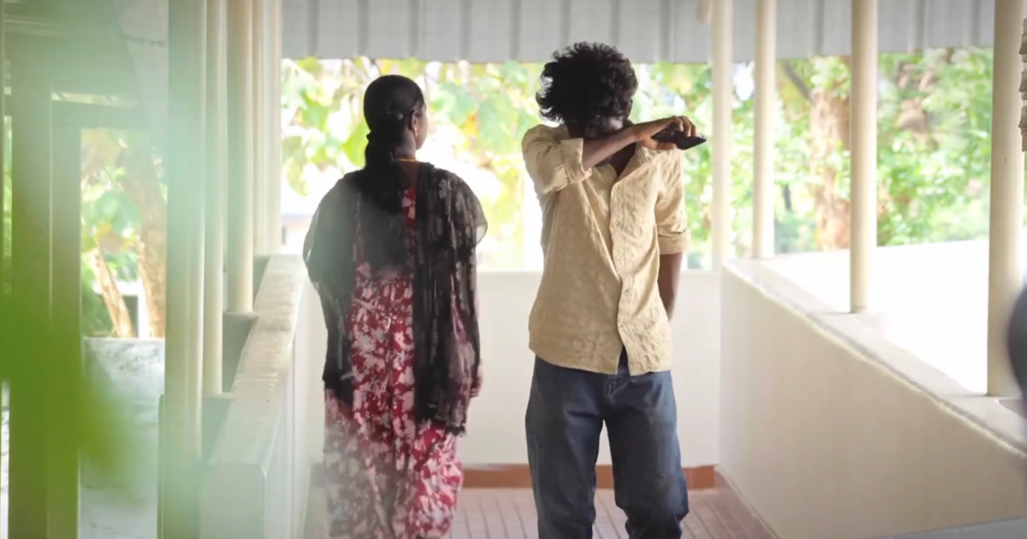

INT. HOSPITAL BREEZEWAY — CONTINUOUS

He stands alone in the empty corridor, gathering himself. Footsteps. ELINA appears beside him — older too, steadier. She doesn't say much. She doesn't need to. She simply stands with him.

ELINA (gently) You don't have to explain it to me, Kevin.

Kevin looks at her — grateful, sad, present in a way he hasn't been in years.

EXT. PATHWAY — DAY

Kevin walks alone through the trees afterward, unhurried. No hologram beside him this time. No phone in his hand. Just him, in the present, finally.

